Chapter 6

Database Design

6.1 Introduction

Database system are the most important feature for a company. It is the backbone of all the information structure. It is the collection of data where data are stored in such a manner that there are inter-related but not redundant information. It helps to maintain information in an orderly process. With these database, the controlling and flexibility has increased. Rajshahi Krishi Unnayan Bank requires many databases as it has to keep control of all the user information. It has loan section, account section and others.

6.2 Database for Rajshahi Krishi Unnayan Bank

Rajshahi Krishi Unnayan Bank is a bank of 383 branches.It has its own data center and data server.It keeps a backup of the whole data in government data center by hiring cloud space.It is very useful in case of system crashes.The database information are related to-

-Account

-Deposit

-Loan

-Employee

-Customer

Besides, the bank is giving E-banking services though prefers manual process.

6.2.1 ER Diagram for Rajshahi Krishi Unnayan Bank

ER diagram resembles the whole process structure. As bank is a secure place, much information was not able to collect. The brief idea is presented here.

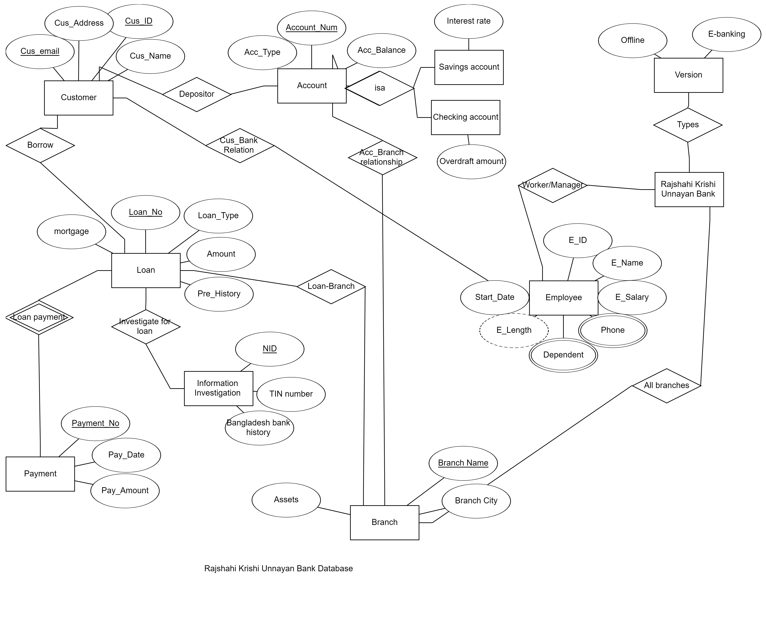

Figure6.1: ER diagram of Rajshahi Krishi Unnayan Bank

6.2.2 Structures of tables

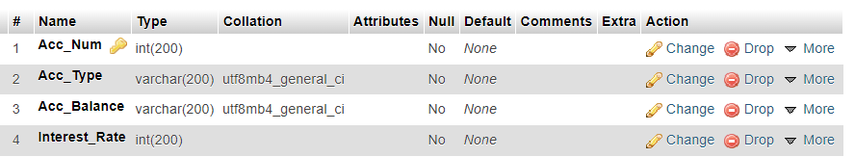account

branch

customer

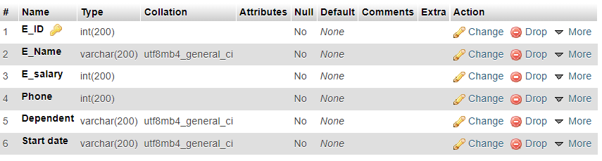employee

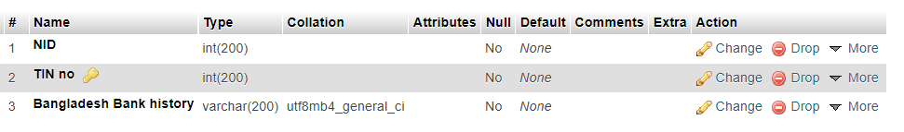investment

loan

payment

6.3 Conclusion